Overview:

* UCSD had 96% throw in accuracy | Air Force was at 75%
* Left flank had less losses per pass than the right side. Left side was slightly more efficient
* Duel Win Rate 50%
  + Defensive duel Win Rate 69.6%
  + UCSD won 77.3% of our duels in our own half
  + 122 offensive duels and a lot of taking players on
  + Kai, Carter and Michael were very successful
  + Max had 18 offensive duels and only won 2
* Forward pass accuracy of 70.9%
* 11 Deep Completed Passes
  + 8 were crosses
  + 42.9% crossing accuracy
  + 1.1 expected goals off crosses of 1.95 xG whole game
* 64% of shot assists are passes/crosses from outside. 81% of shot assists that are passes are from outside
* 25% of UCSD Chances from Set Pieces | 25% from UCSD Tackles | 25% from pass interceptions
* Losses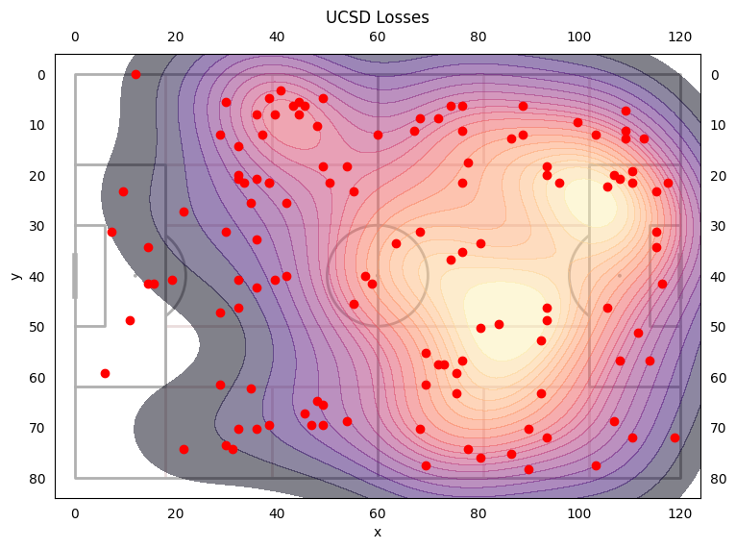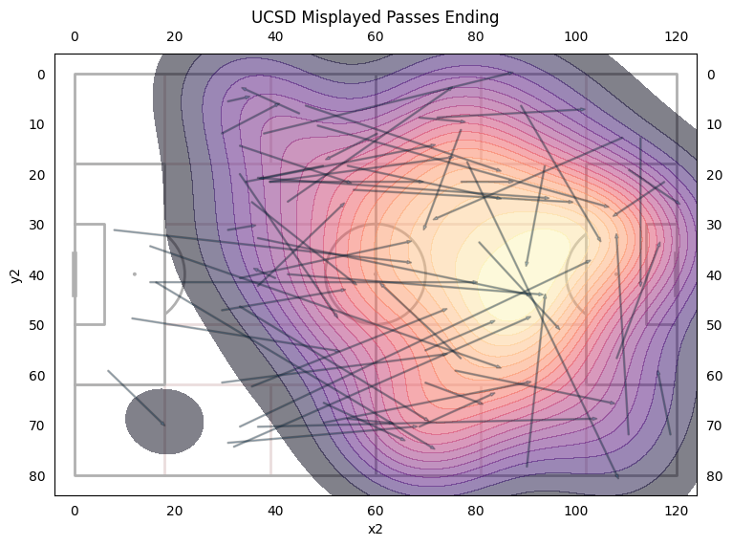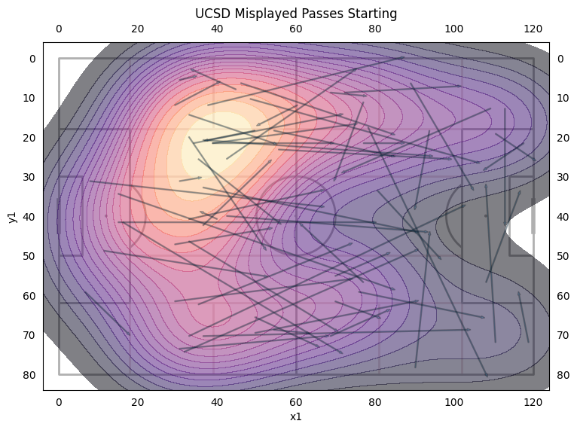
* 53.6% of our losses are on the left side
* 46.4% of our losses are no the right side
* Carter and McGee had the most losses at 15, then Max at 13, then Evan, Cole, and Quinn at 10.
* Defensive duel Win Rate 69.6%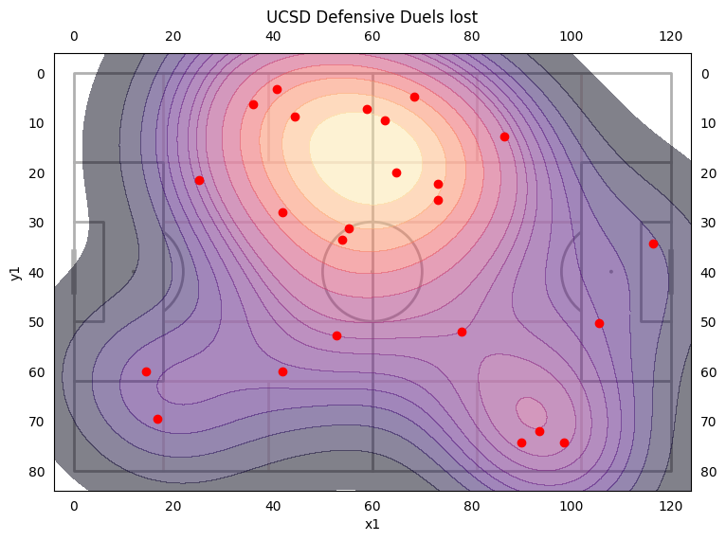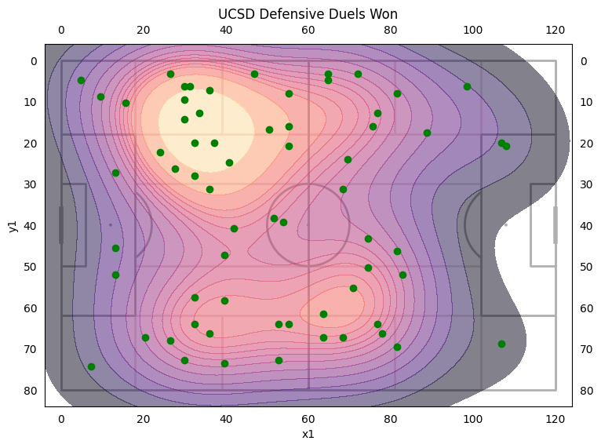
* UCSD won 77.3% of our duels in our own half | Highest all season
  + Left side won 75.7% | Right side won 80%
* Highest Winning Players: Carter (100%) 9 duels, Adam (100%) 6 duels, Evan (100%) 3 duels, Woody (80%) 5 duels, Quinn (77%) 13 duels
* Lowest Winning Players: Michael (33%) 3 duels, Matt (50%) 8 duels, Max (50%) 4 duels
* Offensive duel win rate 36% with 122 offensive duels (A lot of taking players on)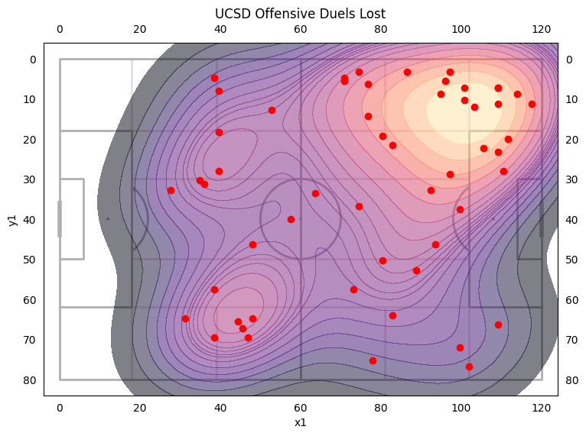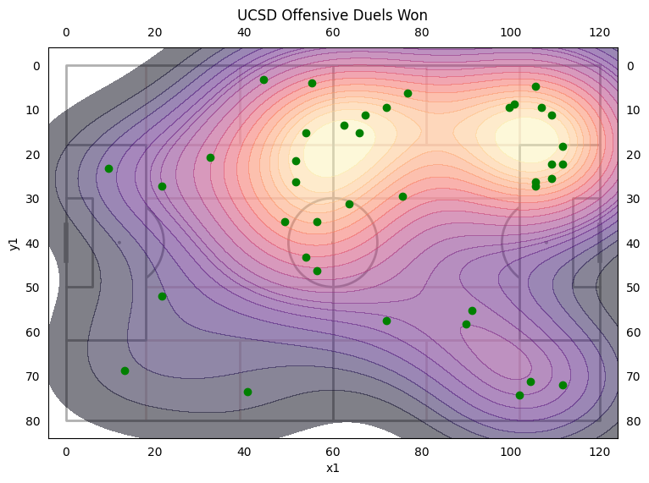
* Highest winning players: Kai (100%) 4 duels, Carter (73%) 11 duels, Michael (67%) 9 duels
* Lowest winning players: Brian (0%) 4 duels, **Max (11%) 18 duels,** Ryan (25%) 4 duels, Quinn (29%) 7 duels
* Forward pass accuracy of 70.9% Highest this season and only 1% off from 72% goal.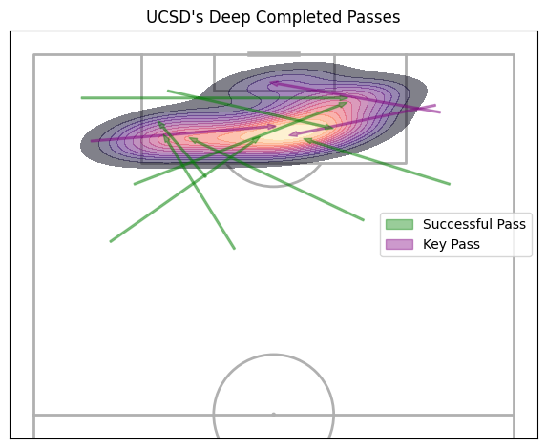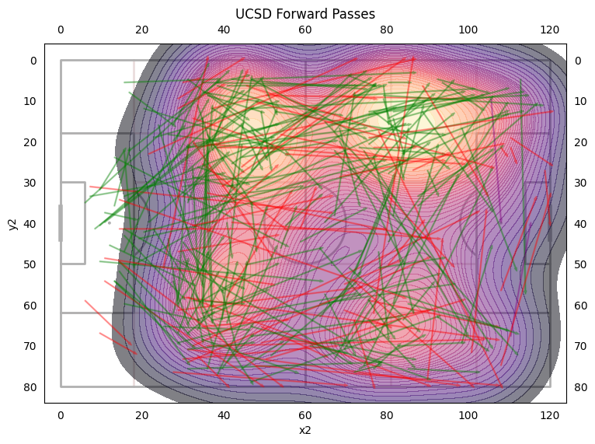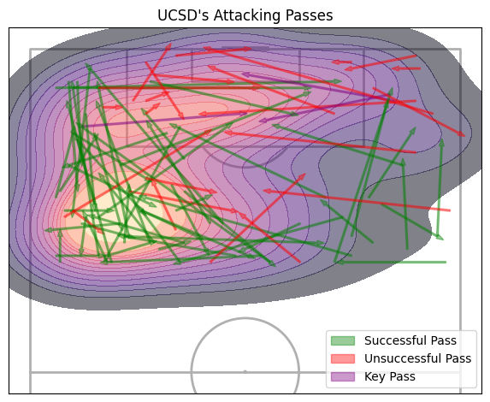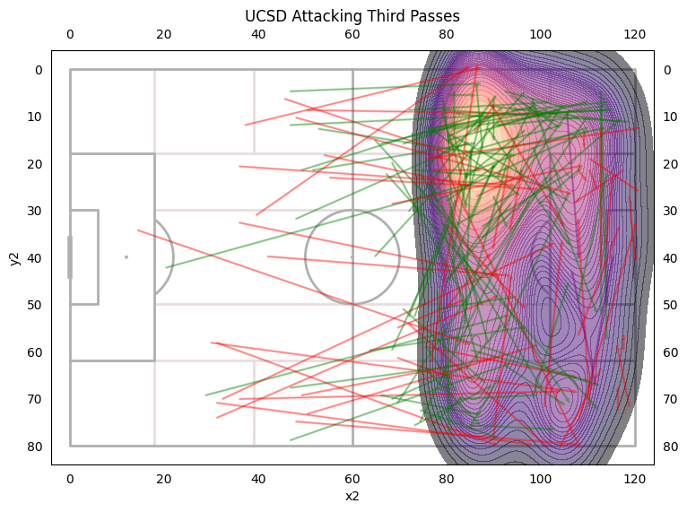
* 45% of forward passes are on the left | 33.7% of passes are on the right
* Left flank was 7% more accurate than the right side.
* 11 Deep Completed Passes | 8 of which were crosses
* Crossing accuracy of 42.9% second highest this season behind lipscomb

Player Forward Passes

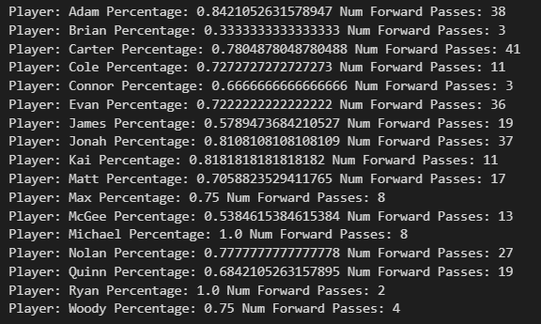

* Highest Accuracy Players: Adam, Jonah, Kai, Carter, Nolan
* Lowest Accuracy Players: Brian, McGee, James

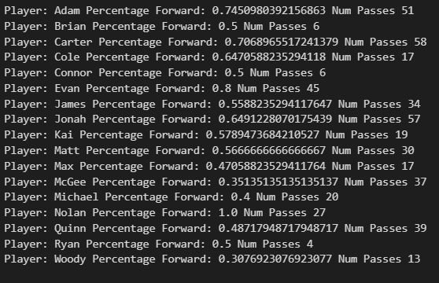

* Quinn only played forward 48.7% of the time and had a lower forward pass accuracy than normal
* James’s forward pass percentage is a little lower for a defensive player

Chance Origins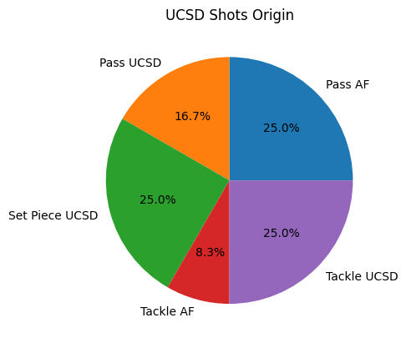

UCSD pass is from Nolan (2 Chances)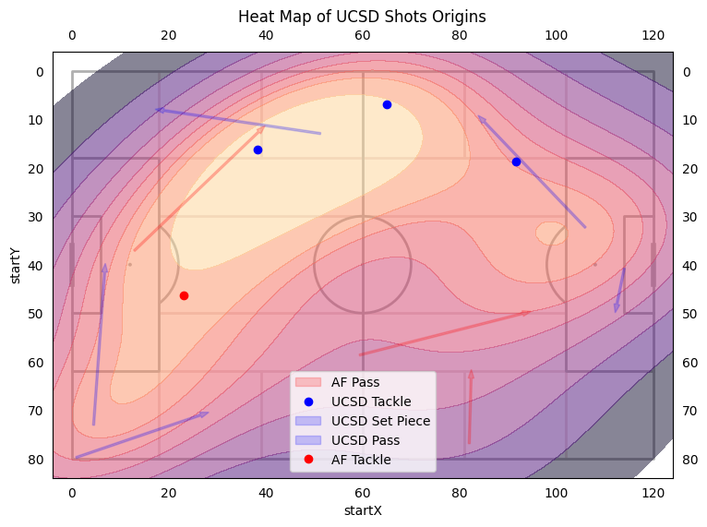

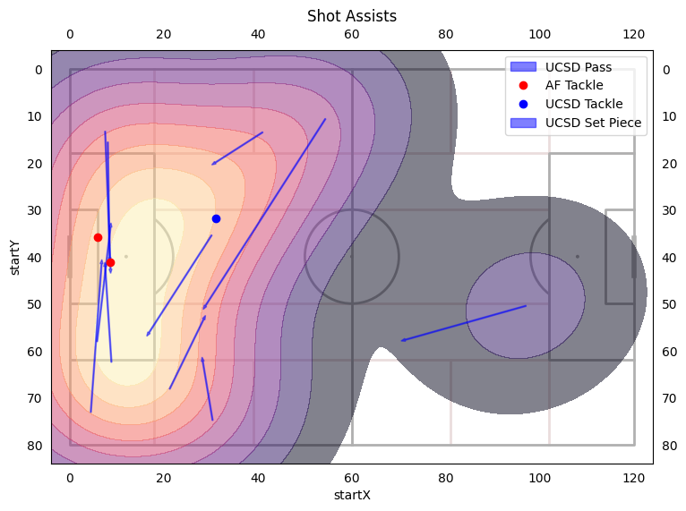

Most shots assists are from out wide 64% of all. 81% of passes